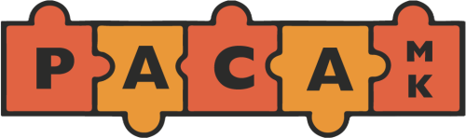
The PACA Mark/Mystery Shopper Scheme
Please tell us about a business or service provider who you think is worthy of a PACA Mark. It can be a play or leisure facility, café or shop, a short break provider or anywhere that you visit with your son/daughter.
When we have received your form, one of our mystery shoppers will visit to assess whether they meet PACA’s criteria to receive an award.
Please complete this form and return it to: PACA, C/o Carers Milton Keynes, Margaret Powell House, 439 Midsummer Boulevard, Milton Keynes, MK9 3BN.
Thank you for your help.
I would like to suggest …………………………………..…… for a PACA Mark because:

Have you visited this venue with a disabled child/person?

Address of business/service:

My details:

Name:

Address:

Email

Phone

